L2TP configure on Windows 7 (64 bit)

Network Topology:
FVS318N (WAN Port) ----------- Windows 7
On FVS318N configure L2TP server:
- configure VPN->L2TP Server 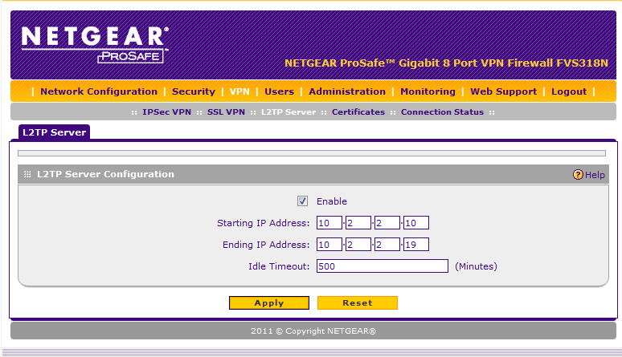
- Add a valid L2TP user in FVS318N
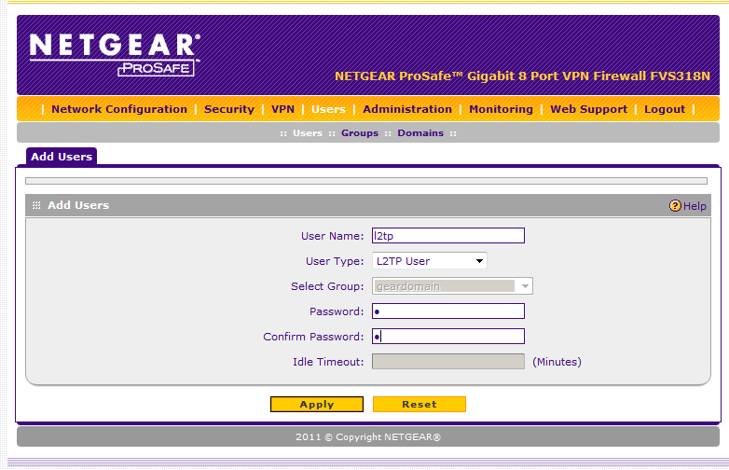

Now, begin to configure L2TP on Windows 7:
- Go to “Network and Sharing”, Set up a new connection or network:
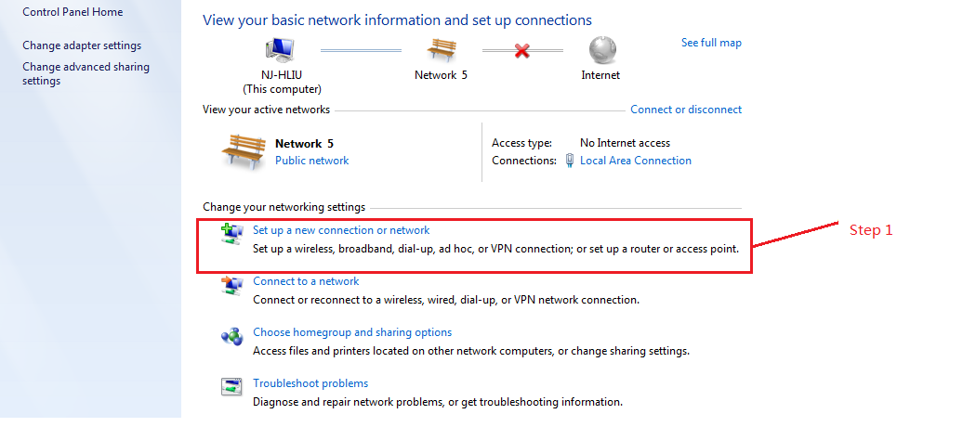
- Connection a workplace:
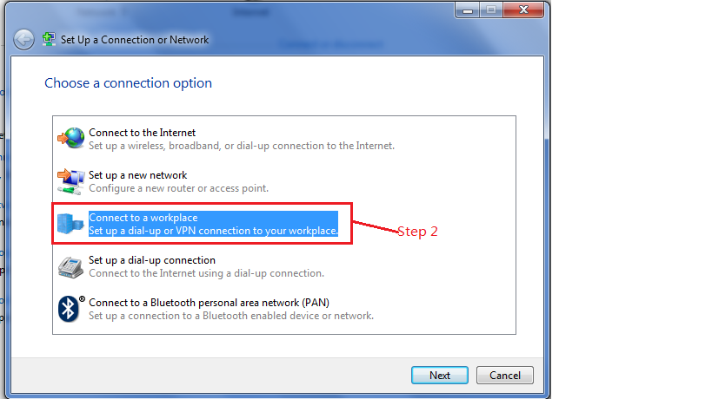
- Use my internet connection (VPN):
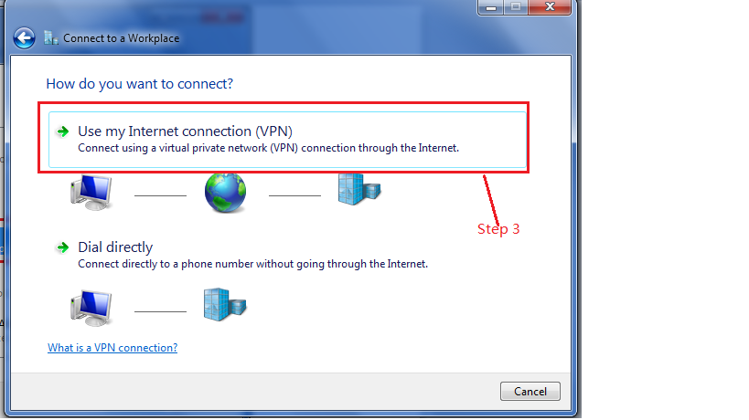
- Set up an Internet connection later:
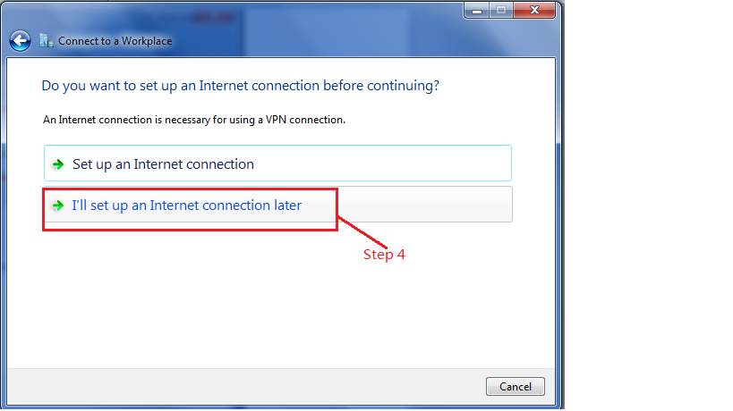
- Type the Internet address to connect to (L2TP Server, here is FVS318N Wan port IP):
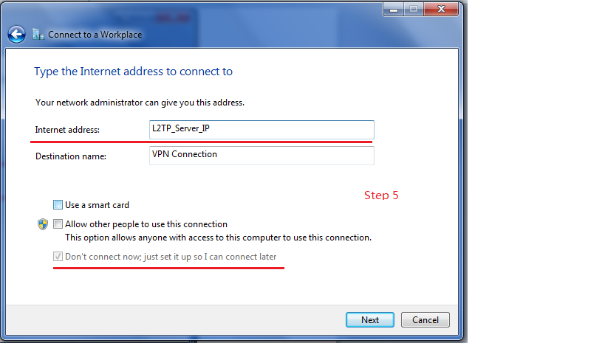
- Input L2TP user and password:
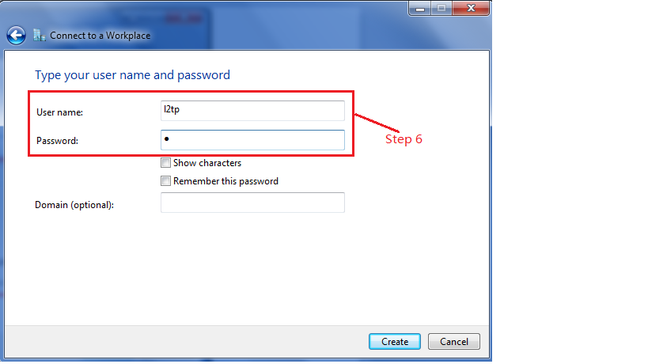
- Modify the type of VPN to L2TP/IPSec:
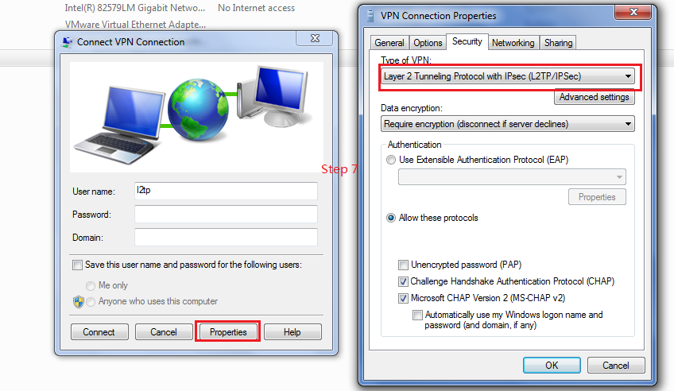
- Modify the registry for not using IPSec encryption (for default Windows L2TP traffic policy must use IPSec encryption):
- Click Start, input “regedt32” at command line and return.
- In registry find: HKEY_LOCAL_MACHINE\System\CurrentControlSet\Services\Rasman\Parameters
- Add a new value named “ProhibitIpSec” whose type is “REG_QWORD”.
- Set the value of “ProhibitIpSec” to 1
- Reboot Windows 7.
- After Windows 7 reboot. Goto “Change adapter settings” and connect VPN connections with valid L2TP user and password:
